

Mini-Project Report for
EE6008 – Deep Learning at the Edge

On

PLANT SEASON DETECTION USING TRANSFER LEARNING TECHNIQUES

Submitted by:

Tanishq Rahul Shelke – 24263583
Rashi Trisholiya – 24240761
Sinduja Ramanan – 24056669
Abraham Mammen – 24317594
Jaikrishna Reddy – 24131989

Abstract:
This project suggests a simple, AI-based solution to plant season determination from visual cues like texture of leaves, flowering stage, and color of leaves. Transfer learning was utilized to fine-tune a pre-trained MobileNetV2 convolutional neural network on a novel image dataset, labeling each image with the respective season (spring, summer, fall, or winter). Model testing and training were supported by the Edge Impulse platform, where the dataset was hosted, preprocessed, and uploaded. Using a comparatively small dataset, transfer learning allowed the model to be effectively fine-tuned to the seasonal classification problem. After training, the model was quantized and deployed on the OpenMV Cam H7 Plus, a low-resource edge hardware with real-time inference capability. The entire system exhibited high classification accuracy at low memory and processing requirements and is suitable for deployment in smart agriculture, environmental monitoring, and autonomous seasonal detection in field conditions.

Introduction:

Plant seasonal changes, visible and valuable for agricultural planning, ornamental design, and environmental monitoring, are characterized by differences in leaf color, flowering stages, and foliage cover. Accurate identification of the spring, summer, autumn, and winter seasons of plants can enable timely pest control, fertilization, irrigation, and aesthetic designs. Recent developments in edge computing and artificial intelligence (AI) have made it feasible to use image-based models that run locally on low-power devices to automate the classification of plant seasons.
We utilized Edge Impulse, a machine learning platform created for edge AI applications, to construct a seasonal plant classification system. Utilizing a distinctive image dataset of ornamental plants categorized by season, we implemented MobileNetV2, a streamlined and effective convolutional neural network architecture, in conjunction with transfer learning to refine the model for our particular classification objective. The resultant model was optimized for edge deployment and executed on the OpenMV Cam H7 Plus microcontroller, showcasing real-time inference capabilities in a resource-limited setting. This project exemplifies a scalable and autonomous solution for intelligent landscaping and climate-responsive plant management.

Background Survey:

Ornamental crops are important in aesthetic and ecological urban planning, improving the visual appeal and microclimate of public and private places. Precisely identifying these phases of the seasons can improve fertilization, irrigation, pruning, and ornament lighting, and influence the appearance of public places.
Traditionally, ornamental plant observation has relied on eye inspection and pre-determined seasonal calendars. AI systems have the potential to overcome reactivity deficiencies of microclimatic changes in traditional methods. With AI-based technologies, we are able to evaluate real-time visual data so that automated and adaptive plant care is possible. Embedded vision technology enables AI systems to classify plant conditions in the field with low-power and compact hardware platforms. MobileNet achieves the best classification accuracy with fewer parameters and computations than standard CNNs. Inverted residual blocks, linear bottlenecks, and additional optimization of inference time and memory were introduced by MobileNetV2, an evolution of this type of architecture that is essential for resource-constrained edge devices such as smart gardening systems.
In contrast to computationally more intensive models such as ResNet or custom CNNs, MobileNetV2 with transfer learning provides the optimal balance of speed, scalability, and accuracy. Its restricted model size, TensorFlow Lite compatibility, and successful deployment on boards such as Edge Impulse and OpenMV make it ideal for real-time edge-based monitoring of ornamental crops.
In recent studies, it is evident that hybrid architectures that integrate MobileNetV2 lightweight with Inception modules improve feature extraction. These hybrid models validate the usefulness of MobileNetV2 in agricultural picture analysis by achieving excellent classification accuracy in such tasks while retaining a low computational footprint. Also, the study proved that transfer learning can be used to successfully adapt generalist CNNs to highly domain-specific tasks, further justifying its application for ornamental season detection in instances of small or unbalanced datasets.[2].
Application in most image classification scenarios outside agriculture is additional proof of MobileNetV2's success with transfer learning. To illustrate this, Patil et al. (2023) used transfer learning to find that a tailored MobileNetV2 model can spot road potholes to perfection with a massive 99.95% classification accuracy. The study proves the multi-application suitability of MobileNetV2, particularly after retraining over task-specific sets of small volume of data—thereby finding extensive application for it in edge-based systems where computing efficiency is to be achieved while maintaining speed and accuracy in inference [3].
System Design:
The plant-season classification workflow was developed with a well-structured and methodologically rigorous AI pipeline that was enabled by the Edge Impulse platform. Each step of the workflow, from data collection to model deployment, was supported by Edge Impulse's graphical user interface and the supporting toolset, which rendered it an efficient and reproducible process well adapted for rapid prototyping and edge AI deployment.
Data collection and annotation: A customized image dataset was developed in order to capture seasonal features of plants across the four primary seasons: spring, summer, autumn, and winter. The photos were collected manually using smartphone cameras under various conditions of natural lighting and open outdoors. Through multiple plant species, multiple backgrounds, and viewpoints, the dataset promoted visual diversity. As visual markers for categorization, prominent seasonal features such as patterns of flowering, differences in leaf color, and densities of leaves were employed. Between 250 and 300 photographs were collected each class. Images were arranged cautiously into season groups, which served as the foundation of supervised learning.
Uploading to Edge Impulse: The lightweight data ingestion front-end of Edge Impulse Studio was utilized to upload the image data set. Four class labels in Spring, Summer, Autumn, or Winter form were utilized for each image during uploading. Out-of-the-box dataset handling of Edge Impulse involved train-test auto-split (traditionally 80/20) and had human-readable adjustability for balancing of classes or correcting mislabeled errors. This stage concluded in a well-structured dataset arrangement suitable for training high-performance machine learning models.
Model selection: MobileNetV2 model was chosen from Edge Impulse's library of pre-integrated models. MobileNetV2 is well-adapted for real-time edge AI use cases as it has been designed to run on low-power and embedded devices. Model architecture uses depthwise separable convolution and inverted residual block, which minimizes memory and computational demands without hindering accuracy[1]. The 96×96 pixel image input size is processed in Edge Impulse's default mode, accepted as the captured resolution prior to preprocessing.
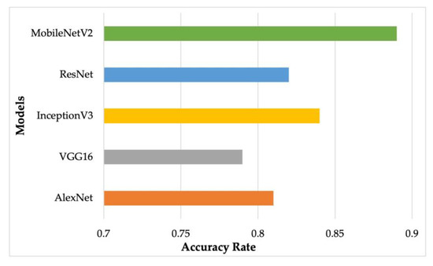
Figure 1 the accuracy of different models achieved while training on the fruit dataset containing forty different types of fruits. From the figure, it is evident that MobileNetV2 achieves the highest accuracy with 89%, which is higher than ResNet

Transfer learning was employed to adapt a pre-trained MobileNetV2 model, which had been originally trained on the ImageNet dataset, to the plant-season classification task at hand. In doing so, the bottom layers of the model preserved their already acquired general visual features, and only the upper classification layers were retrained on the project-specific dataset. This gradually decreased the training time and improved performance, in terms of the low size of the sample. Transfer learning allows the model to generalize effectively to seasonal plant traits acquiring limited labeled data.
Model training setup: Edge Impulse provides real-time status of model training, including accuracy, loss curves, and confusion matrices. These criteria facilitated for evaluation and refining of the model's well-labeled performance across four seasonal classes.
The training parameters were configured as follows:
- Number of Epochs: 30
- Batch Size: 32
- Optimizer: Adam (default)
- Loss Function: Categorical Crossentropy
- Learning Rate: 0.0005
- Quantization: Enabled (Int8 format) for edge compatibility

Module Deployment selection: An OpenMV Cam H7 Plus, a microcontroller-based edge device with constrained memory and processing power, was used to test the optimized and quantized model. Edge Impulse offered direct export of the trained model in TensorFlow Lite (TFLite) format, suitable for deployment on OpenMV hardware. The OpenMV IDE is used to host the camera module, python's built-in tf.load() and infer() functions were used to carry out the inference. The deployment requires no additional scripting or adjustments to the model, in terms of the accessibility.

Dataset Collection:
The set comprised some 1,200 photos altogether, spread rather evenly across the four seasonal sets. Each set had between 280 and 310 photos, with the totals varying slightly in accordance with natural variation in seasonally distinct images during the time of data capture.
Variations in Lighting, Angles, and Backgrounds: Images were also captured over a variety of distances and angles to mimic user viewpoint variations. Backgrounds were comprised of grass, sky, walls, and surrounding plants, adding natural noise and complexity to the dataset.
Data Augmentation Using Edge Impulse Tools: To increase the effective dataset size and replicate real-world variation, augmentation techniques like zooming, horizontal flips, brightness, and random rotations were used. These transformations avoided overfitting and enhanced the performance of the model in accurately classifying unseen images.
Labeling and Class Balance: To ensure consistency and dependability in the training process, each image was manually labeled with the season based on visual cues. A more consistent classification performance throughout all seasons was facilitated by the balanced class distribution, which also helped prevent model bias.

Model Training and Evaluation:
- Training and Validation Metrics:
The model was trained over 30 epochs with categorical cross-entropy as the loss function and the Adam optimizer. The input photos were scaled to 96×96 pixels, matching the input dimensions required by MobileNetV2. Edge Impulse projected real-time results of loss progression, training and validation accuracy during the training process.
- Final Training Accuracy: 93.8%
- Validation Accuracy: ~95.6%
- Training Loss: 0.14
- Validation Loss: 0.

- F1 Score, Precision, and Recall:
For the final model, the following averaged categorization metrics were reported:
- Precision: 0.96
- Recall: 0.95
- F1 Score: 0.95
There was a limitation observed as visual overlap between Spring and Summer due to similar color palettes and leaf hue. Environmental noise (e.g., cluttered backgrounds, low light) which affected prediction confidence.

Results:
The system responsiveness was not well-suited for quick real-time feedback due to microcontroller restrictions. Nonetheless, the model's predictions were congruent with human assessments, demonstrating its utility for autonomous, on-device plant monitoring.
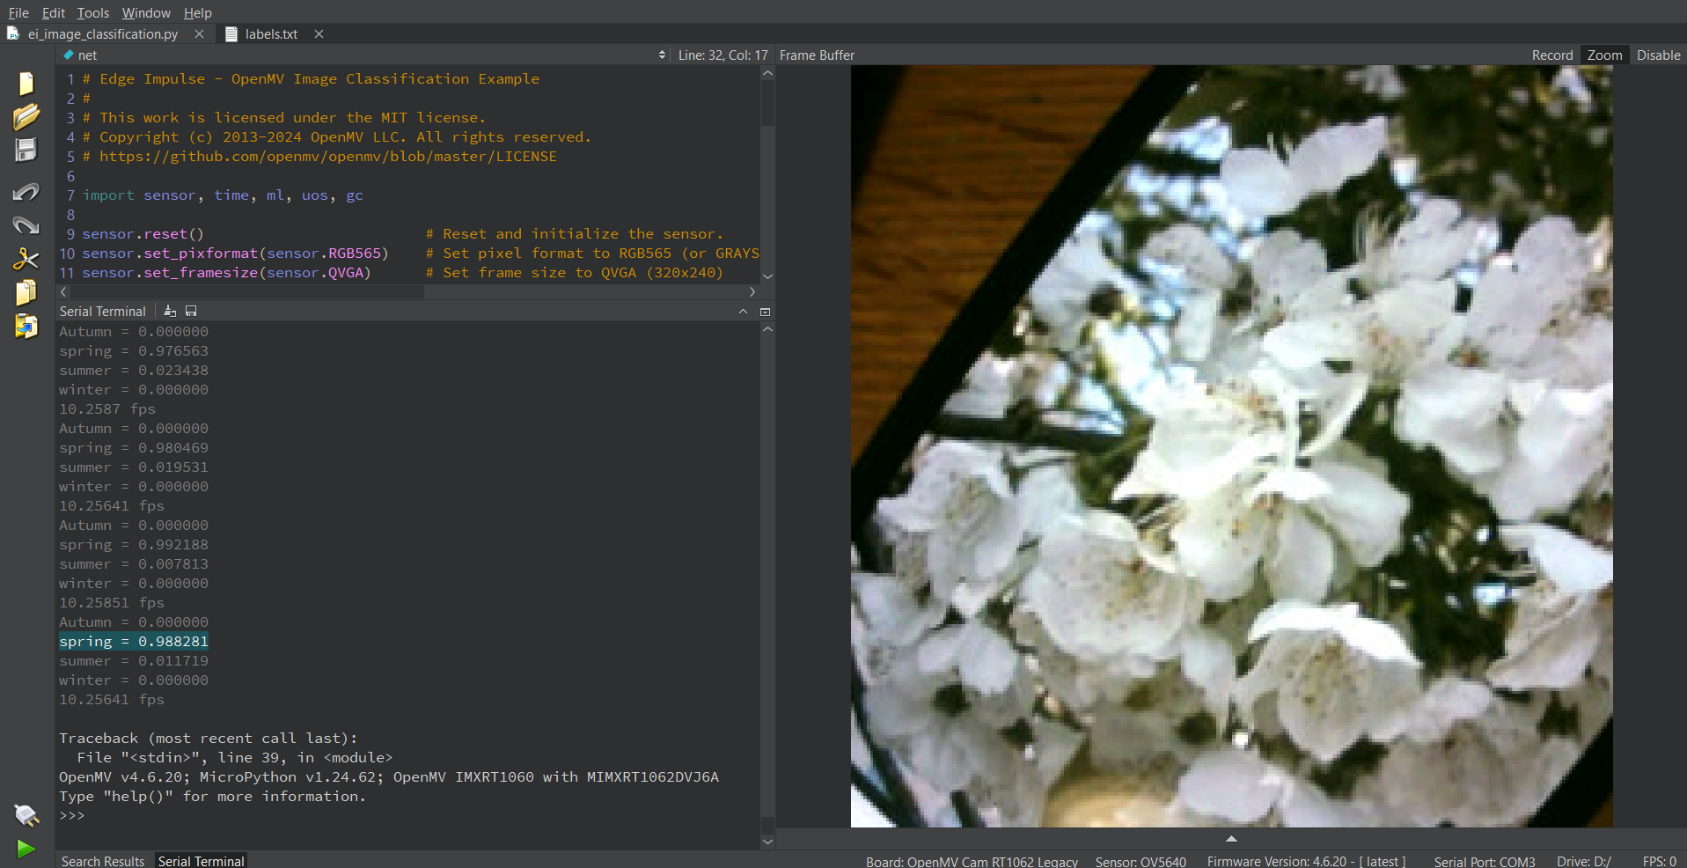
For real-time detection, model predictions were executed via the OpenMV IDE:
Figure 2 Detection of a cherry blossom plant indicating spring season

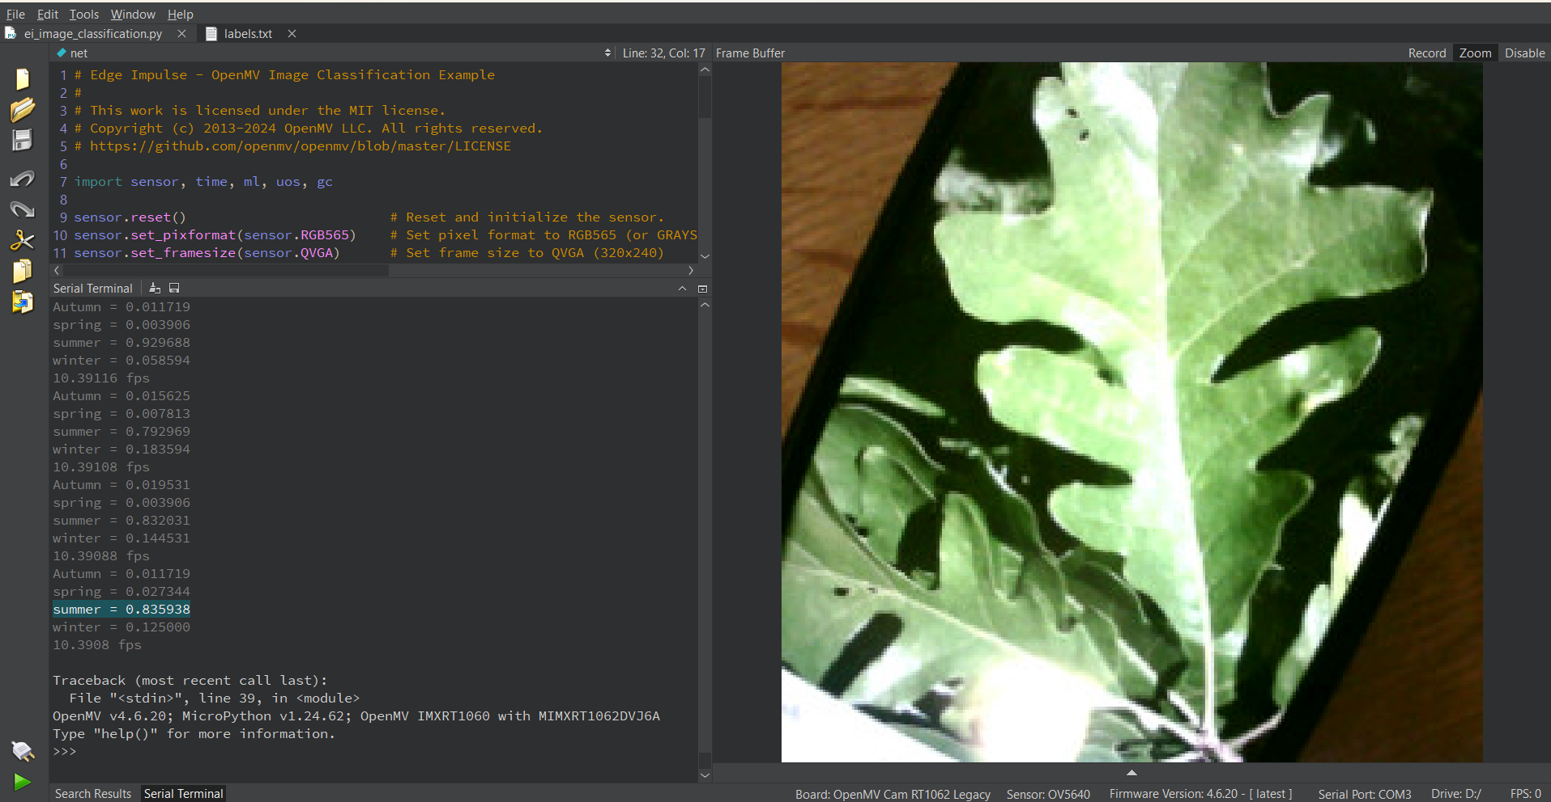
Figure 3 Detection of a bur oak tree indicating summer season

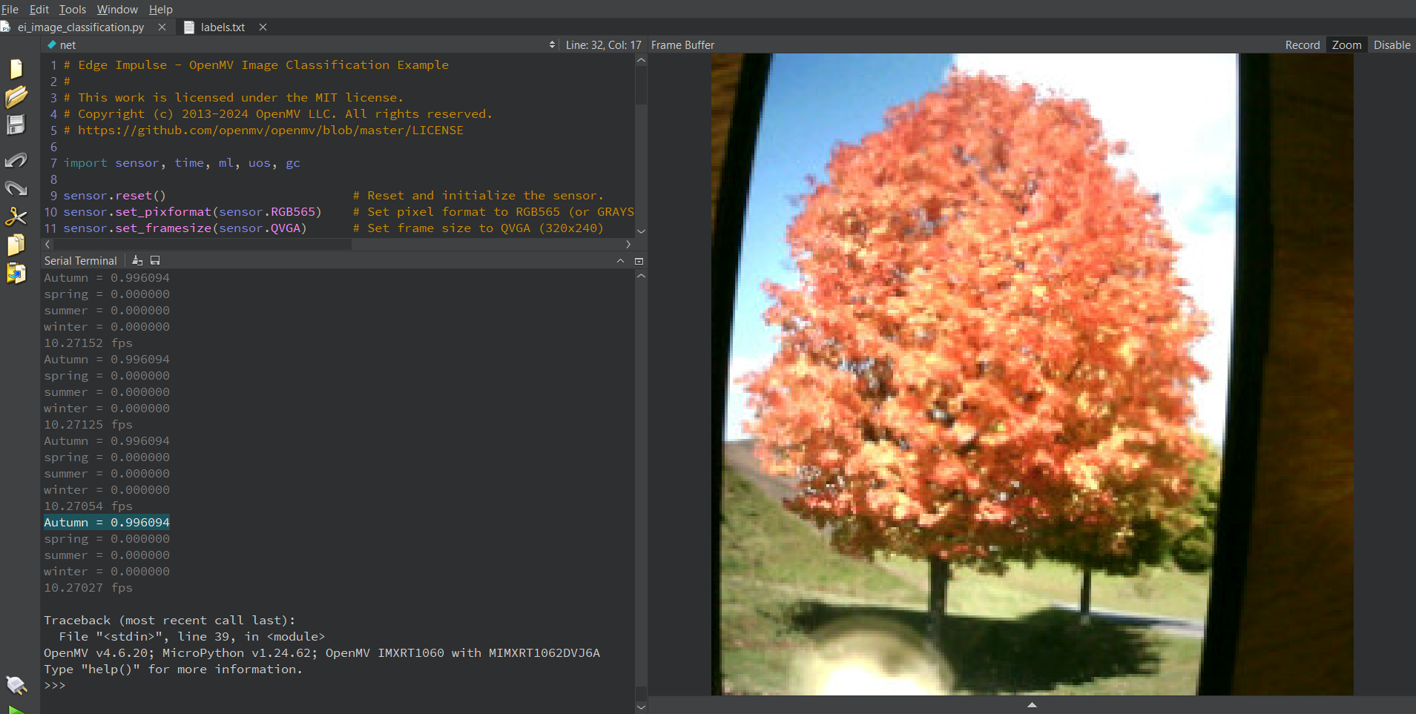
Figure 4 Detection of a red maple tree indicating autumn season

Challenges and Limitations:
Plant-seasonal detection model project was promising ones, yet while applying transfer learning, numerous challenges and limitations were faced. These challenges identify areas to be refined and offer points for improvement.
Class Similarity and Dataset Limitations:
The most challenging task in this project was to obtain a suitably large and balanced dataset. The seasonality of the plant photos meant that it was challenging to have an equal number of representative images for each of the four seasons in the same time frame and geographic location. Since, the visual of the intermediate leaves overlap between spring and summer classes, including color hues, leaf thickness, and vibrant lighting, causing false prediction. Such overlapping features decreased inter-class separability, reducing accuracy under some conditions. To address these issues, the no. of dataset were increased through Edge Impulse's onboard feature and some data augmentation techniques (e.g., random brightness modification and rotations). Additional improvement, however, would necessitate the expansion of the dataset across varied geographic regions and climates.
Overfitting:
The model indicated overfitting in the early training runs, with validation accuracy plateauing at 89% while training accuracy surpassed 98%. The smaller sample size and low intra-class variance contributed to this outcome. The small sample size and comparatively low intra-class variance were a contributing factor to this outcome.
The following were the strategies that were used in a bid to prevent overfitting:
- Activation of the Edge Impulse data augmentation process.
- Reduction of the epochs number (e.g., from 50 to 30) so that the model will not over-simplify the training set.
- Dropout regularization used in the last classifier layer made easier by the MobileNetV2 training configuration.
- Early stopping mechanism using validation performance trends.
Conclusion:
This project demonstrated a lean, AI-based solution for plant season classification from visual features and transfer learning with MobileNetV2. Developed on the Edge Impulse platform and executing on the OpenMV Cam H7 Plus, the model achieved strong accuracy (~95.6%) with low resource requirements, suitable for real-time edge deployment in agriculture and environmental surveillance. Despite problems like seasonal overlap and scarce data, approaches such as augmentation and regularization improved performance. The system gives a scalable solution for intelligent, on-device monitoring of plants.
Future developments may include:
- Dataset Expansion and Diversification: To increase model resilience and class separability, future iterations should use additional photos from a wider variety of ornamental species, geographical locations, and lighting situations.
- Increasing Frame Rates: Future implementations might consider hardware with greater processing power or more refined model structures for applications that need quicker response.
- Context-Aware and Weather-Aware Inference: By integrating location-based seasonal indicators and real-time weather data, the system may be able to automatically modify categorization thresholds or confidence levels in response to the current environmental circumstances.

References-
[1]"Fruit Image Classification Model Based on MobileNetV2 with Deep Transfer Learning Technique."
[2]”MobileNetV2-Incep-M: A Hybrid Lightweight Model for the Classification of Rice Plant Diseases”
[3]"Modified MobileNetV2 Transfer Learning Model for Pothole Detection"

Name | Signature | Key Contributions | Estimated % Contribution
Tanishq Rahul Shelke
Rashi Trisholiya | 
Sinduja Ramanan
Abraham Mammen
Jaikrishna Reddy | 

